MS-606
ORGANIZATIONAL BEHAVIOR
Detailed Exam Study Guide
Based on the uploaded syllabus + OB2 + OB3 + Emotions & Moods slides

EXAM FOCUS
The syllabus explicitly emphasizes: definitions, case studies, analytical questions, components of attitude, Affective Events Theory (AET), the OB model, diversity, abilities, job satisfaction, and emotions/moods. The syllabus also states a total of 6 questions.

IMPORTANT SOURCE NOTE
The syllabus lists “Objectives” under OB 1, but no separate OB 1 objectives slide/file was supplied. This guide therefore explains the concepts actually supported by the uploaded materials and flags any place where a slide only names a concept without defining it.

Contents
1. How to use this guide / syllabus map
2. OB Fundamentals and Management
3. Diversity, Discrimination, and Ability
4. Attitudes and Job Satisfaction
5. Emotions and Moods
6. Cross-topic analytical links and case-study framework
7. Practice Questions: descriptive + analytical + case-based
8. Six-question mock exam
9. Last-minute revision sheets
Exam strategy
For direct-definition questions, write the course definition first, then one sentence of explanation and one example. For case/analytical questions, identify the concept, quote the relevant facts of the case, apply the concept, and finish with the likely organizational implication.

1. Syllabus Map and Coverage Check
The uploaded syllabus is the controlling checklist. It lists OB 1, OB 2, job satisfaction, emotions, case studies, and an exam pattern of descriptive + case-study + analytical questions (6 questions total).
Syllabus item | Where covered in this guide | Priority
OB 1: Objectives | Flagged: no separate objectives material uploaded | Know broad purpose of OB from supplied definition
OB 1: What is OB? | Section 2.5 | High
Management functions | Section 2.1 | High
Mintzberg managerial roles | Section 2.2 | High
Skills | Section 2.3 | High
Managerial activities | Section 2.4 | High
Exhibit 1-3: behavioural sciences + contributions | Section 2.6 | High
Challenges & opportunities | Section 2.7 | Medium (1/2-mark emphasis in syllabus)
OB model / Exhibit 1-4 | Section 2.8 | Very high
Diversity levels | Section 3.1 | High
Forms of discrimination | Section 3.2 | High
Abilities | Section 3.4 | High
Job satisfaction | Section 4 | Very high
Emotions & moods | Section 5 | Very high
Components of attitude | Section 4.1 | Very high
AET | Section 5.9 | Very high
Case studies 3+4+2 | Section 6 + case bank | High

How to interpret “3+4+2”
The supplied syllabus says “Topics for case studies in OB (3+4+2) each” but does not define the grouping. To avoid inventing the instructor’s exact allocation, the practice bank below contains 9 original mini-cases spanning the three major blocks: 3 OB/diversity, 4 attitudes/job satisfaction, and 2 emotions/AET.

2. OB Fundamentals and Management

2.1 Management Functions
The slides give two formulations:
Fayol (5 functions) | Robbins (4 functions) | Meaning for exam answers
Planning | Planning | Set goals and decide how to achieve them.
Organizing | Organizing | Arrange work, people, authority, and resources.
Commanding | Leading | Direct and influence employees; motivation and guidance.
Coordinating | — | Integrate activities so parts of the organization work together.
Controlling | Controlling | Monitor results against plans and correct deviations.

Course source: OB2 slide 2. The slide explicitly notes Fayol’s five functions and that Robbins condensed them to planning, organizing, leading, and controlling. The management meanings above are explanatory study notes.
Memory hook
P-O-L-C = Plan → Organize → Lead → Control. Fayol’s “commanding” and “coordinating” are absorbed into the modern four-function formulation.

2.2 Mintzberg’s Managerial Roles
Mintzberg grouped managerial work into three role families: interpersonal, informational, and decisional.
Role family | Role | What the manager does
Interpersonal | Figurehead | Acts as the symbolic head; performs routine legal or social duties.
Interpersonal | Leader | Motivates, directs, and supports employees.
Interpersonal | Liaison | Maintains a network of outside contacts that provides favors and information.
Informational | Monitor | Receives a wide variety of information; serves as an information nerve center.
Informational | Disseminator | Transmits information from outsiders or employees to members of the organization.
Informational | Spokesperson | Transmits information about plans, policies, actions, and results to outsiders; acts as an organizational/industry expert.
Decisional | Entrepreneur | Searches for opportunities and initiates projects to bring change.
Decisional | Disturbance handler | Takes corrective action when unexpected disturbances occur.
Decisional | Resource allocator | Makes or approves significant decisions about organizational resources.
Decisional | Negotiator | Represents the organization in major negotiations.

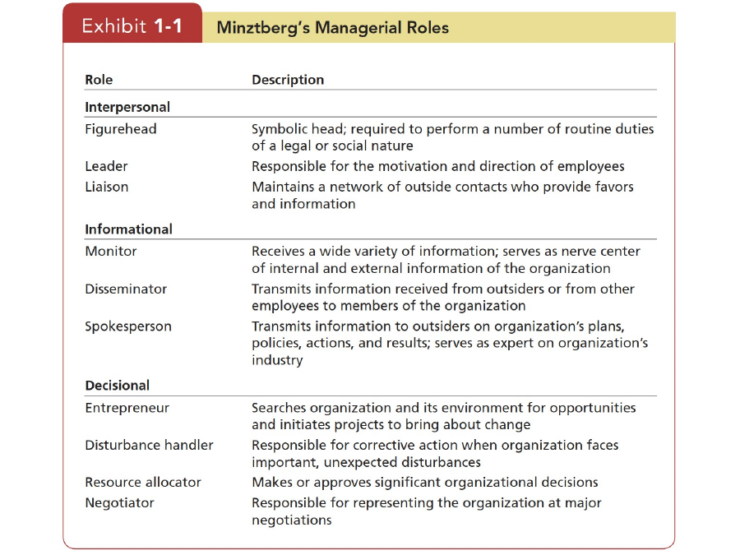
Source visual: OB2 slide 4 — Mintzberg's Managerial Roles.
How to solve a case question
Look for the verb: ceremonial appearance → figurehead; motivate/direct → leader; outside network → liaison; gather information → monitor; pass information internally → disseminator; speak externally → spokesperson; start change → entrepreneur; handle crisis → disturbance handler; decide where money/people go → resource allocator; bargain → negotiator.

2.3 Management Skills
Skill | Explanation | Typical case clue
Technical skills | Knowledge and competence in a specific job, process, technology, or method. | Manager must understand the actual work or technical system.
Human skills | Ability to work effectively with people: communicate, motivate, resolve conflict, and build relationships. | Interpersonal problems, teamwork, conflict, morale.
Conceptual skills | Ability to think abstractly, see the organization as a whole, and understand how parts fit together. | Strategic problems, long-term consequences, cross-functional issues.

The uploaded slide names these three skills but does not define them. The explanations above are explanatory notes for study; the names themselves are directly from OB2 slide 5.

2.4 Managerial Activities (Luthans)
Activity | Meaning | Examples from slide
Traditional management | Core managerial process work. | Decision making, planning, controlling.
Communication | Routine information exchange and information processing. | Exchanging routine information, paperwork.
Human resource management | Managing people and employee-related processes. | Motivating, disciplining, conflict management, staffing, training.
Networking | Building relationships beyond immediate formal tasks. | Socializing, political activity, interacting with outsiders.

OB2 slide 6 attributes these four categories to Fred Luthans.

2.4A Successful vs. Effective Managers
Type in the course | Definition in slide | What to remember
Successful manager | Defined by speed of promotion within the organization. | Promotion speed.
Effective manager | Defined by quantity and quality of performance plus employee satisfaction and commitment. | Performance + people outcomes.

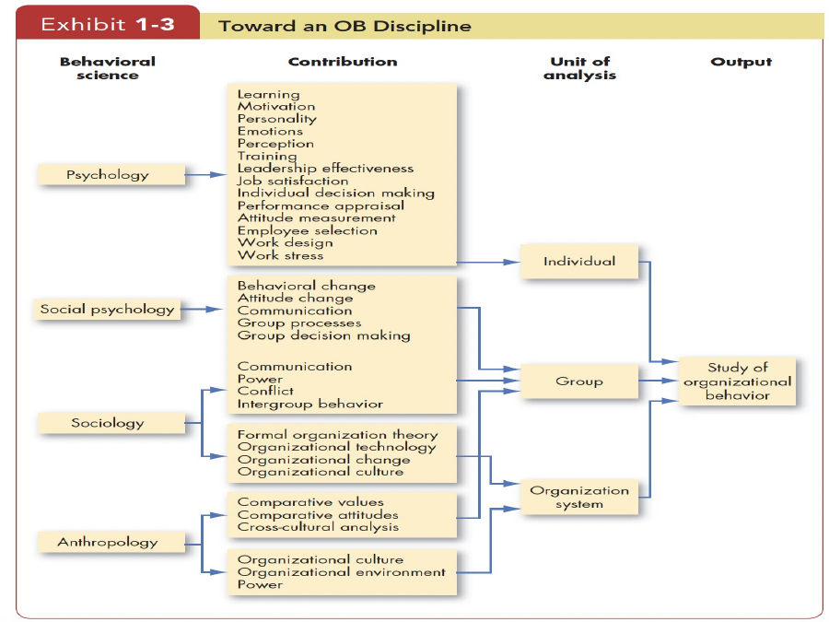
OB2 Exhibit 1-3 appears later; the time-allocation exhibit is on slide 7 and visually contrasts average, successful, and effective managers.
The slide’s chart shows that the activity mix differs between average, successful, and effective managers. The key conceptual point is that rapid promotion and broad organizational effectiveness are not defined identically.

2.5 What is Organizational Behavior (OB)?
Organizational behavior (OB): A field of study that investigates how individuals, groups, and structure affect behavior within organizations, with the purpose of applying that knowledge to improve organizational effectiveness.
The supplied OB2 slide emphasizes three determinants: individuals, groups, and structure. OB therefore asks what people do in organizations and how that behavior affects organizational performance. fileciteturn0file1L35-L39
One-line exam answer
OB = the systematic study of what people do in organizations, how individuals/groups/structure influence behavior, and how that knowledge can improve organizational effectiveness.

2.6 Disciplines Contributing to OB — Exhibit 1-3
Behavioral science | Main contribution shown in exhibit | Primary unit of analysis
Psychology | Learning, motivation, personality, emotions, perception, training, leadership effectiveness, job satisfaction, individual decision making, performance appraisal, attitude measurement, employee selection, work design, work stress. | Individual
Social psychology | Behavioral change, attitude change, communication, group processes, group decision making; the exhibit also links communication, power, conflict and intergroup behavior to the group level. | Group
Sociology | Group behavior; communication, power, conflict, intergroup behavior; formal organization theory, organizational technology, organizational change, organizational culture. | Group + organization system
Anthropology | Comparative values, comparative attitudes, cross-cultural analysis; organizational culture, organizational environment, power. | Group + organization system

“Behavioral science — what?”
Psychology mainly helps explain the individual/micro level; social psychology focuses on influence between people; sociology examines people in social environments and group/organizational structures; anthropology adds culture, values, and cross-cultural understanding.

2.7 Challenges and Opportunities for OB
The syllabus explicitly marks this area as a possible 1/2-mark topic. Memorize the list and attach one sentence of meaning to each.
Topic | What it means
Economic pressures | Organizations must manage employee behavior while responding to changing economic conditions.
Globalization | Managers operate across countries, cultures, and labor markets.
Foreign assignments | Employees may need to work successfully in unfamiliar cultural settings.
Different cultures | Managers must adapt communication and management to cultural differences.
Movement of jobs to low-cost countries | Managers face outsourcing/offshoring decisions and their people consequences.
Workforce diversity | Organizations contain people with different demographic and deep-level characteristics.
Customer service | Employee behavior directly affects customer experience.
People skills | Managers need strong communication, interpersonal, and conflict-management skills.
Innovation and change | Organizations need behavior that supports adaptation and innovation.
Networked organizations | Work is increasingly distributed through interconnected relationships and technology.
Work–life conflicts | Managers must handle tension between work demands and nonwork responsibilities.
Positive work environment | Organizations seek climates that support employee well-being and constructive behavior.
Ethical behavior | Managers must encourage conduct consistent with ethical standards.

2.8 Basic OB Model — Exhibit 1-4
The model is a cause/process/outcome framework with feedback from outcomes back toward future inputs.
Level | Inputs | Processes | Outcomes
Individual | Diversity, personality, values | Emotions & moods, motivation, perception, decision making | Attitudes & stress, task performance, citizenship behavior, withdrawal behavior
Group | Group structure, group roles, team responsibilities | Communication, leadership, power & politics, conflict & negotiation | Group cohesion, group functioning
Organization | Structure, culture | Human resource management, change practices | Productivity, organizational survival

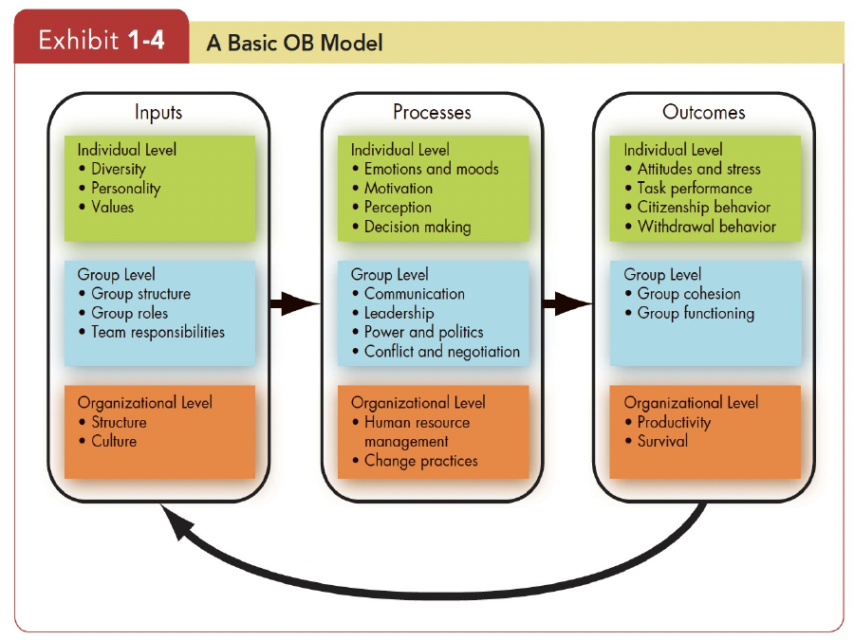
OB2 Exhibit 1-4 — A Basic OB Model.

Key outcomes — memorize these definitions
Outcome | Definition / meaning from slides
Attitudes | Employee evaluations, positive or negative, about objects, people, or events.
Stress | An unpleasant psychological process occurring in response to environmental pressures.
Task performance | Combination of effectiveness and efficiency in core job tasks.
Citizenship behavior | Discretionary behavior outside formal job requirements that contributes to the psychological and social environment; performance beyond expectations.
Withdrawal behavior | Actions employees take to separate themselves from the organization; described in the slide as performance below expectations.
Group cohesion | Extent to which group members support and validate one another at work.
Group functioning | Quantity and quality of a work group’s output.
Productivity | Combination of organizational effectiveness and efficiency.
Organizational survival | Degree to which an organization can exist and grow over the long term.

3. Diversity, Discrimination, and Ability

3.1 Levels of Diversity
Type | Definition | Exam clue
Surface-level diversity | Differences in easily perceived characteristics such as gender, race, ethnicity, age, or disability. These do not necessarily reflect how people think/feel but may activate stereotypes. | Visible/demographic differences.
Deep-level diversity | Differences in values, personality, and work preferences that become more important for judging similarity as people get to know one another. | Invisible or less immediately visible differences.

Discrimination: Making judgments about individuals based on stereotypes regarding their demographic group.
Case method
First identify whether the case concerns visible demographics (surface-level) or values/personality/preferences (deep-level). Then check whether there is discriminatory behavior, an accommodation issue, or simply diversity without discrimination.

3.2 Forms of Discrimination — Exhibit 2-1
Form | Definition from course exhibit
Discriminatory policies or practices | Actions by organizational representatives that deny equal opportunity to perform or provide unequal rewards for performance.
Sexual harassment | Unwanted sexual advances and other verbal or physical conduct of a sexual nature that creates a hostile or offensive work environment.
Intimidation | Overt threats or bullying directed at members of specific groups of employees.
Mockery and insults | Jokes or negative stereotypes; sometimes jokes taken too far.
Exclusion | Excluding certain people from job opportunities, social events, discussions, or informal mentoring; may occur unintentionally.
Incivility | Disrespectful treatment, including aggressive behavior, interruption, or ignoring another person’s opinions.

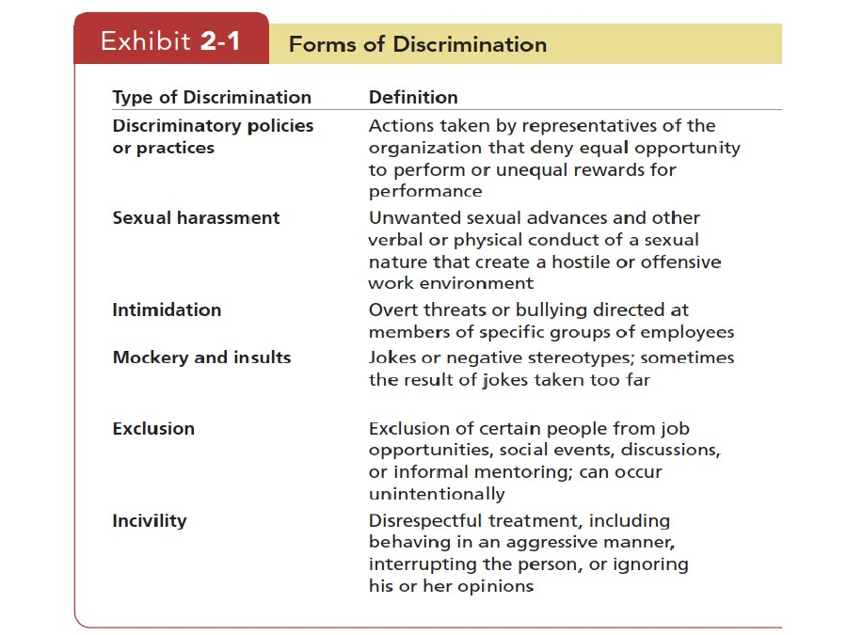
OB2 Exhibit 2-1 — Forms of Discrimination.

3.3 Biographical Characteristics
Characteristic | Course points
Age | The slides ask students to consider the relationship between age and job performance and between age and job satisfaction.
Gender | The slides discuss possible differences in job performance, workplace behavior, work schedules, and turnover rates.
Race and ethnicity | The slides note interaction discomfort without clear behavioral scripts and state that race/ethnicity can affect hiring, evaluations, pay, and workplace discrimination; ethnic discrimination can lead to negative outcomes.
Disability | Employers are required to make accommodations so workplaces are accessible to individuals with physical or mental disabilities; the slides note effects on performance outcomes and evaluation.
Tenure | Expressed as work experience; the slides state a positive relationship between seniority and job productivity.
Religion | Employees with different religious faiths may experience conflict.
Sexual orientation & gender identity | The slides note organizational policies protecting employees on the basis of sexual orientation and policies concerning treatment of transgender employees.

Use source wording carefully
The biographical-characteristics slides present relationships and possible workplace effects rather than saying every listed characteristic always causes a specific outcome. In a case answer, describe the condition in the facts before drawing the organizational implication.

3.4 Ability
Ability: An individual’s capacity to perform the various tasks in a job.
Intellectual abilities: Capacity to perform mental activities such as thinking, reasoning, and problem solving.
General Mental Ability (GMA): An overall factor of intelligence, generalized across cultures.
Physical abilities: Capacity to perform tasks that demand stamina, dexterity, and strength.

3.4A Seven Dimensions of Intellectual Ability
Dimension | Description from Exhibit 2-2 | Typical example
Number aptitude | Ability to do speedy and accurate arithmetic. | Compute totals or numerical values.
Verbal comprehension | Ability to understand what is read or heard and the relationship of words to one another. | Understand instructions.
Perceptual speed | Ability to identify visual similarities and differences quickly and accurately. | Spot an error or mismatch.
Inductive reasoning | Ability to identify a logical sequence in a problem and then solve the problem. | Infer the rule from examples.
Deductive reasoning | Ability to use logic and assess the implications of an argument. | Draw a conclusion from premises.
Spatial visualization | Ability to imagine how an object would look if its position in space were changed. | Mentally rotate an object.
Memory | Ability to retain and recall past experiences. | Recall procedures or information.

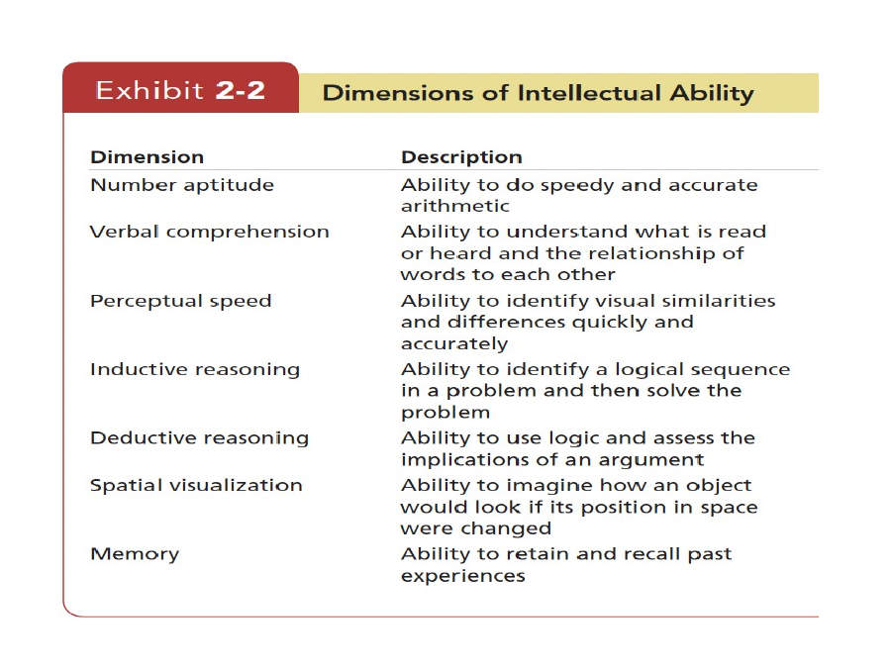
OB2 Exhibit 2-2 — Dimensions of Intellectual Ability.

3.4B Nine Basic Physical Abilities
Category | Ability | Meaning
Strength | Dynamic strength | Exert muscular force repeatedly or continuously over time.
Strength | Trunk strength | Exert muscular strength using trunk/abdominal muscles.
Strength | Static strength | Exert force against external objects.
Strength | Explosive strength | Expend maximum energy in one or a series of explosive acts.
Flexibility | Extent flexibility | Move trunk and back muscles as far as possible.
Flexibility | Dynamic flexibility | Make rapid, repeated flexing movements.
Other | Body coordination | Coordinate simultaneous actions of different body parts.
Other | Balance | Maintain equilibrium despite forces pulling off balance.
Other | Stamina | Continue maximum effort requiring prolonged effort over time.

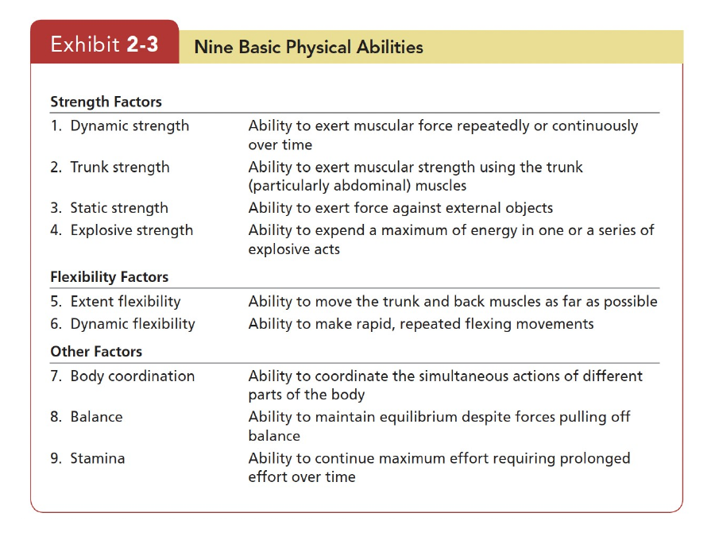
OB2 Exhibit 2-3 — Nine Basic Physical Abilities.

3.5 Diversity Management
Diversity management: The process and programs by which managers make everyone more aware of and sensitive to the needs and differences of others.
Stage | Course point
Attracting | Target recruiting messages to specific demographic groups underrepresented in the workforce.
Selecting | Qualifications should be more important in determining hiring than demographic characteristics.
Developing | The slide notes that people whose personality traits are similar to co-workers/supervisors are more likely to be promoted.
Retaining | A positive diversity climate is related in the slide to higher organizational commitment and lower turnover intentions.

3.6 Diversity in Groups
- The course slide states that demographic diversity does not, by itself, increase or decrease team performance.
- Teams of highly intelligent individuals are more effective; the slide therefore notes that diversity on these variables is likely to decrease performance.
- Diverse groups are described as more effective when leaders can show members that they have a common interest in the group’s success.
Case application
Do not assume “diverse = better” or “diverse = worse.” Use the particular variable, task, group process, and leadership conditions described in the case.

3.7 Effective Diversity Programs
1. Teach managers the legal framework for equal employment opportunity and encourage fair treatment regardless of demographic characteristics.
2. Teach managers how a diverse workforce can be better able to serve a diverse customer/client market.
3. Foster personal-development practices that bring out the skills and abilities of all workers.

4. Attitudes and Job Satisfaction

4.1 What is an Attitude?
Attitude: An evaluative statement—favorable or unfavorable—about objects, people, or events; it reflects how we feel about something.
Classic example
“I like my job” = an attitude because it is an evaluation of the job.

4.1A The Three Components of an Attitude (ABC)
Component | Meaning | Course example
Cognitive | Description/belief about how things are. | “My pay is low.”
Affective | Emotional or feeling segment. | “I am angry over how little I’m paid.”
Behavioral | Intention to behave in a particular way toward someone/something. | “I’m going to look for another job that pays better.”

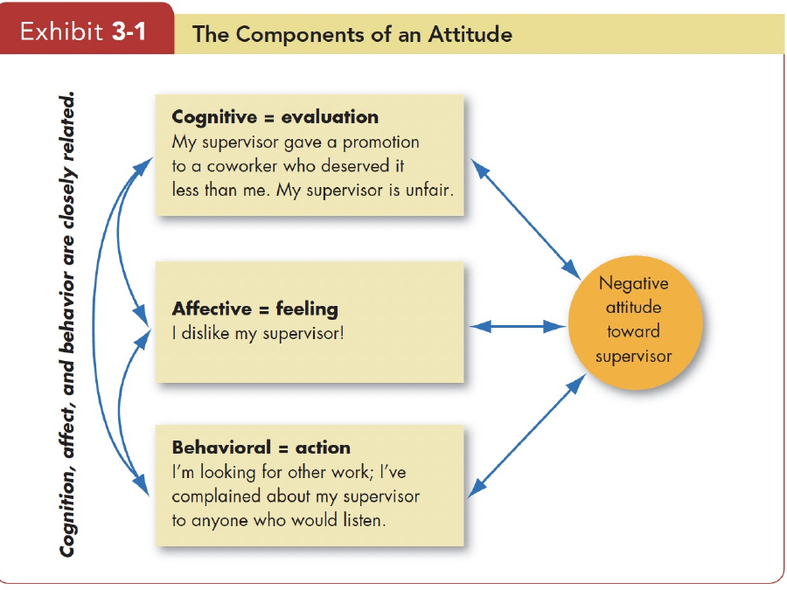
OB3 Exhibit 3-1 — The Components of an Attitude.
Memory hook
C-A-B = Cognition (think) → Affect (feel) → Behavior (intend/do). In a case, identify all three rather than naming only the emotion.

4.2 Does Behavior Always Follow from Attitudes?
The slides describe a change in how researchers understood the attitude–behavior link:
- Early research assumed attitudes were causally related to behavior.
- Leon Festinger argued that attitudes can follow behavior.
Cognitive dissonance: Any incompatibility a person perceives between two attitudes or between behavior and attitudes.
- Inconsistency is uncomfortable, so people try to reduce it.
- People may change an attitude, change behavior, or develop a rationalization for the discrepancy.
- The slide also mentions “rewards of dissonance”; because no further definition is supplied in the uploaded content, do not invent a specific formula or mechanism for it.
Case example
An employee says, “I value honesty,” but then knowingly reports false numbers. The inconsistency creates dissonance. The employee may change behavior, change the attitude (“everyone does it”), or rationalize the mismatch.

4.3 Major Job Attitudes
Job attitude | Definition | Fast distinction
Job satisfaction | Positive feeling about one’s job resulting from evaluation of its characteristics. | How I feel about my job.
Job involvement | Degree to which people identify psychologically with their job and see perceived performance as important to self-worth. | How central the job is to my identity/self-worth.
Psychological empowerment | Belief about influence over the work environment, competence, meaningfulness, and autonomy. | I can influence/control meaningful work.
Organizational commitment | Degree to which an employee identifies with an organization and its goals and wishes to remain a member. | Attachment to the organization.
Perceived organizational support (POS) | Belief that the organization values the employee’s contribution and cares about well-being. | Does my organization value/care about me?
Employee engagement | Involvement with, satisfaction with, and enthusiasm for the work the employee does. | Energy/enthusiasm toward the work.

4.4 Measuring Job Satisfaction
Method | How it works | Strength in an exam answer
Single global rating | Ask one overall question such as “All things considered, how satisfied are you with your job?” and use a rating scale. | Fast, broad overall assessment.
Summation of job facets | Rate separate facets such as work, supervision, pay, promotion, and co-workers, then combine the ratings. | More detailed diagnosis of which job aspects drive satisfaction.

Exam comparison
Global rating asks “overall, how satisfied?” Facet/summation asks “how satisfied are you with specific parts of the job?” The uploaded slide asks whether one is superior; it does not supply a single universal winner.

4.5 Causes of Job Satisfaction
- Interesting jobs that provide training, variety, independence, and control are associated in the slide with greater satisfaction.
- Interdependence, feedback, social support, and interaction with co-workers outside the workplace are strongly related to job satisfaction.
- Pay can motivate people, but what motivates a person is not necessarily identical to what makes that person happy.
- Positive core self-evaluations—belief in one’s inner worth and basic competence—are associated in the slide with higher job satisfaction.
Remember
Do not reduce job satisfaction to salary. The slide explicitly highlights job design, social relationships/support, and core self-evaluations as well.

4.6 Employee Responses to Dissatisfaction — EVLN
Response | Course definition | Typical behavior
Exit | Dissatisfaction expressed through behavior directed toward leaving the organization. | Quit, search for another job.
Voice | Active and constructive attempts to improve conditions. | Complain constructively, propose fixes, use formal channels.
Loyalty | Passively waiting for conditions to improve. | Stay and wait.
Neglect | Allowing conditions to worsen. | Reduced effort, lateness, ignoring problems, etc.

Memory hook
EVLN = Exit, Voice, Loyalty, Neglect. The question may give behavior first and ask you to classify the response.

4.7 Favorable Job Attitudes and Organizational Performance
Virtuous cycle: Having satisfied employees tends to improve later financial performance, which can in turn improve later employee satisfaction.

Important relationships
Relationship | What the uploaded slides say
Satisfaction ↔ job performance | The slides state there is strong support for a satisfaction–performance relationship.
Satisfaction → OCB | Satisfied employees may speak positively about the organization, help others, and go beyond normal expectations as reciprocity for positive experiences.
Satisfaction → customer satisfaction | For frontline employees with regular customer contact, satisfied employees increase customer satisfaction and loyalty.
Satisfaction ↔ absenteeism | The slides describe a consistent negative relationship, but note that sick-leave policies and alternative job availability can affect the relationship.
Satisfaction → turnover | The relationship depends on alternative job prospects; plentiful opportunities make dissatisfaction more likely to translate into turnover. High human capital can also make dissatisfaction more likely to translate into turnover.
Dissatisfaction → workplace deviance | The slides associate job dissatisfaction and antagonistic co-worker relationships with undesirable behaviors such as substance abuse, stealing, excessive socializing, tardiness, and related counterproductive behavior.

4.8 Perception Gap
Perception gap: The gap between what managers think employees feel and what employees actually feel about job satisfaction.
- Some managers may be unconcerned about satisfaction.
- Others overestimate how satisfied employees are and therefore miss problems.
- Regular employee surveys can reduce the gap.
The slide gives an example of a KFC manager who surveys employees every three months.

4.9 Employer–Employee Loyalty: Two Sides in the Course
Position presented in slides | Core reasoning
Point: Linda Gratton | The slide presents an argument that shortening contracts, outsourcing, automation, and multiple careers have weakened traditional loyalty; employers reduce commitments and employees may move when better offers appear.
Counterpoint: Tom Peters / Binna Kandola | The slides present loyalty as still important: committed and engaged employees can find meaning in work, and workplace relationships can remain strong despite changes.

Exam technique
This is a compare/contrast topic, not a definition. Present both arguments and then relate the tension to organizational commitment, engagement, labor mobility, and changing employment arrangements.

5. Emotions and Moods

5.1 Why Emotions Matter in OB
- The course notes that OB historically gave emotions relatively little attention.
- A “myth of rationality” treated emotion as the opposite of rationality.
- Strong negative emotions were often treated as disruptive to effective work.
- The later OB view in the slides is that emotions can be critical to rational thinking and therefore should be considered rather than simply removed from the workplace.
Exam phrase
The key course idea is not “emotion replaces reason”; it is “good decisions use both thinking and feeling.”

5.2 Affect, Emotions, and Moods
Concept | Course definition | Key features
Affect | Broad range of feelings people experience, including emotions and moods. | Umbrella term.
Emotion | Intense feeling directed at someone or something. | Specific trigger, more fleeting, often action-oriented, often shown through distinct facial expressions.
Mood | Less intense feeling than an emotion and often arises without a specific event acting as a stimulus. | Longer lasting, more general, often cognitive, usually not tied to a distinct target.

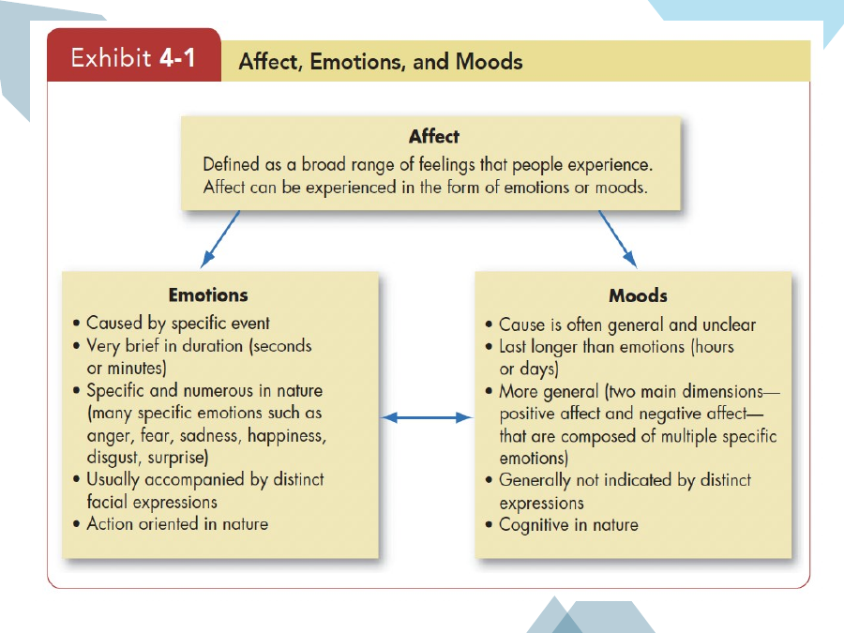
Emotions & Moods — course exhibit on the relationship between affect, emotions, and moods.

5.3 Emotions vs. Moods — High-yield comparison
Dimension | Emotions | Moods
Duration | Fleeting; seconds/minutes in the exhibit. | Hours/days.
Trigger | Usually caused by a specific event. | Cause often general or unclear.
Target | Directed at a person/event/object. | Not usually directed at a specific person/event.
Specificity | Numerous and specific: anger, fear, sadness, happiness, disgust, surprise, etc. | More general dimensions such as positive/negative affect.
Expression | Often accompanied by distinct facial expressions. | Generally not indicated by distinct expressions.
Orientation | Action-oriented. | More cognitive/general.

Transition idea
An emotion can turn into a mood when you lose focus on the event/object that started the feeling. Conversely, a good or bad mood can make you more emotional in response to an event.

5.4 Basic Emotions
The slide lists many possible emotions: anger, contempt, enthusiasm, envy, fear, frustration, disappointment, embarrassment, disgust, happiness, hate, hope, jealousy, joy, love, pride, surprise, and sadness.
It then notes that researchers have tried to identify a fundamental set, including René Descartes’ six “simple and primitive passions”: wonder, love, hatred, desire, joy, and sadness.
The course states that psychologists have also studied facial expressions and that cultures have norms governing emotional expression. The six essentially universal emotions named in the slide are:
Universal emotion in the course | Remember
Happiness | One of the six identified as essentially universal.
Surprise | One of the six.
Fear | One of the six.
Sadness | One of the six.
Anger | One of the six.
Disgust | One of the six.

Distinguish two lists
The slide’s long list illustrates many emotions; the “six universal” list is the smaller set the course highlights as essentially universal.

5.5 Basic Moods: Positive and Negative Affect
Positive affect: A mood dimension consisting of positive emotions such as excitement, self-assurance, and cheerfulness at the high end, and boredom, sluggishness, and tiredness at the low end.
Negative affect: A mood dimension consisting of nervousness, stress, and anxiety at the high end, and relaxation, tranquility, and poise at the low end.
The course also notes that neutral means being nonemotional. Grouping emotions into positive and negative categories produces mood states.
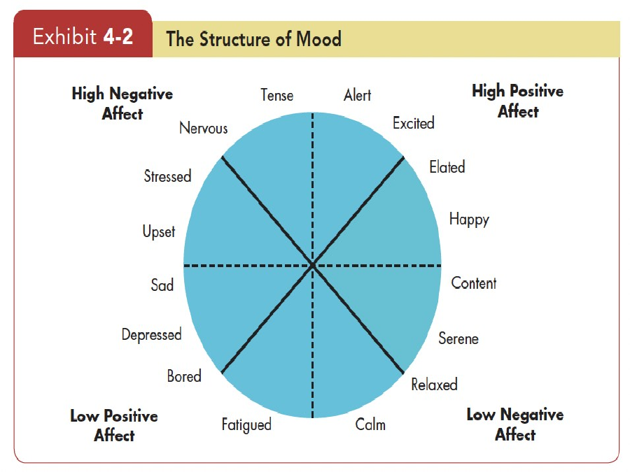
Course exhibit — The Structure of Mood.
How to read the mood structure
High positive affect = energized/enthusiastic; low positive affect = bored/fatigued. High negative affect = tense/nervous/stressed; low negative affect = calm/relaxed/serene.

5.6 Other Points about Moods
- Negative emotions are likely to translate into negative moods.
- People recall negative experiences more readily than positive ones.
- Positivity offset: when there is no particular event or input, most people experience a mildly positive mood.

5.6A Day of Week and Time of Day
The course includes two visuals:
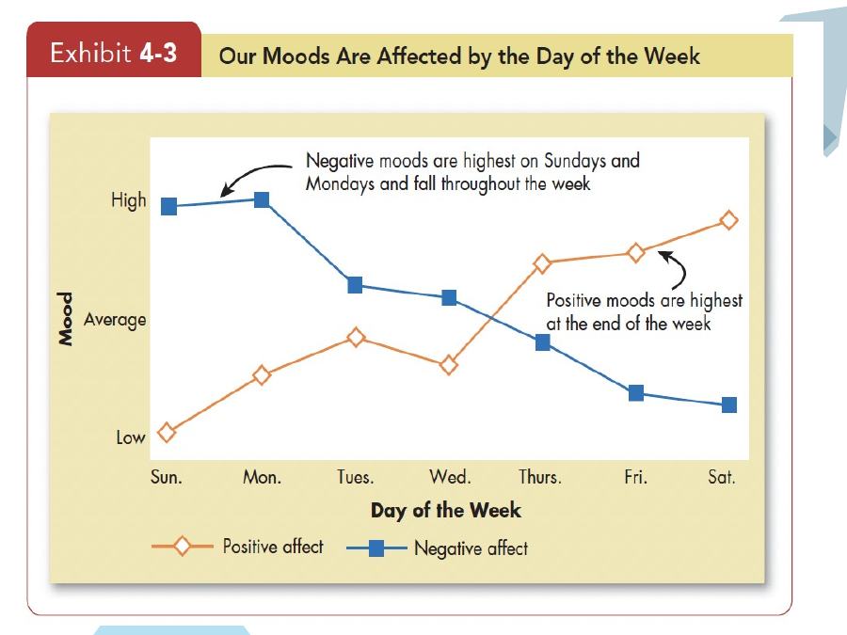
Exhibit 4-3 — moods affected by day of the week.
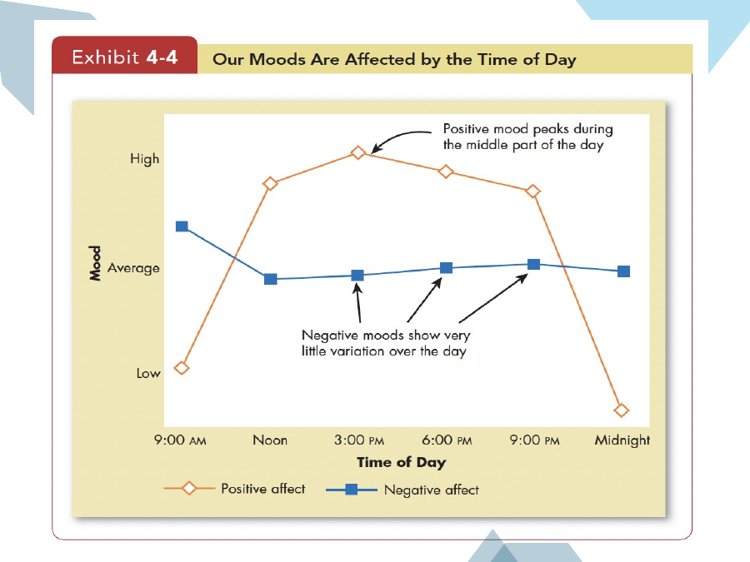
Exhibit 4-4 — moods affected by time of day.
- Day-of-week chart: negative mood is highest around Sunday/Monday and declines across the week; positive mood is highest toward the end of the week.
- Time-of-day chart: positive mood rises through the day and peaks around the middle of the day in the exhibit; negative mood shows relatively little variation across the day.

5.6B Moods of the Unemployed
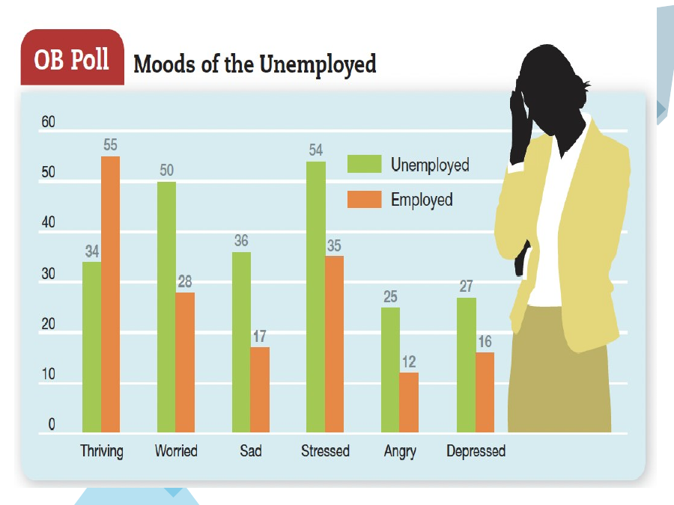
Course poll — moods of unemployed vs. employed respondents.
The chart compares the percentages reported for “thriving,” “worried,” “sad,” “stressed,” “angry,” and “depressed” for unemployed vs. employed groups. In a case, use it as a descriptive comparison rather than claiming the chart proves why the groups differ.

5.7 Emotions & Cultures
The course slides make several cross-cultural observations:
- People around the world interpret positive and negative emotions in broadly similar ways, but cultures place different values on particular emotions.
- The slide reports that people in China reported fewer positive and negative emotions, while Taiwanese respondents were described as more like U.S. workers, reporting more positive and fewer negative emotions.
- The slide says U.S. culture values enthusiasm, while the Chinese context presented in the slide treats negative emotions as potentially more useful/constructive.
- The slide presents pride as generally positive in Western cultures such as the United States but as undesirable in Eastern cultures such as China and Japan.
Exam caution
These statements are course-slide comparisons. In an analytical answer, attribute them to the cultural examples in the course material rather than turning them into universal claims about every person in a culture.

5.8 Function of Emotions

Do emotions make us irrational?
- The older view treated rationality and emotion as being in conflict.
- The course’s later point is that emotions are critical to rational thinking.
- Phineas Gage is used as the course example to support the importance of emotion in decision making.
- The key conclusion in the slide is that good decision making uses both thinking and feeling.

Do emotions make us ethical?
The course notes that ethical decision making had traditionally been based heavily on cognition, but moral emotions also shape ethical reactions.
- Sympathy for the suffering of others.
- Guilt about one’s own immoral behavior.
- Anger about injustice done to others.
- Contempt for people who behave unethically.
These reactions are described in the slide as being largely based on feelings rather than cognition alone.

5.9 Sources of Emotions and Moods
Source | Course point
Personality / affect intensity | People differ in affect intensity—how strongly they experience emotions.
Weather | The slide uses “illusory correlation” to describe associating nice weather and mood even when the events may have no real connection.
Social activities | Physical, informal, or epicurean activities are more strongly associated with increases in positive mood than formal or sedentary events.
Stress | Listed as a source that can shape emotional states.
Sleep | Poor/reduced sleep impairs decision making and makes emotional control difficult.
Exercise | The slide refers to “sweat therapy.”
Age | Emotional experience is described as improving with age.
Gender | The slide presents a finding about reactions being interpreted differently for women and men; treat this as the course’s cited observation rather than a universal rule.

5.10 Emotional Labor
Emotional labor: A situation in which an employee expresses organizationally desired emotions during interpersonal transactions at work.
The concept emerged from studies of service jobs. The key challenge is that employees may have to display one emotion while actually feeling another; this disparity is called emotional dissonance.
Term | Meaning | Example
Felt emotions | The employee’s actual emotions. | Employee genuinely feels frustrated.
Displayed emotions | Emotions the organization requires/convenes as appropriate to show. | Employee must appear warm and calm.
Surface acting | Hiding inner feelings and foregoing emotional expressions in response to display rules. | Smile and sound friendly while actually angry.
Deep acting | Trying to modify true inner feelings to fit display rules. | Reappraise the interaction so genuine warmth is produced.
Emotional dissonance | Disparity between felt and displayed emotions. | Feeling angry but having to display friendliness.

Case clue
If the case says “the employee pretended to be happy,” think surface acting. If the employee tries to genuinely change the feeling, think deep acting.

5.11 Affective Events Theory (AET)
Affective Events Theory: A model suggesting that workplace events cause emotional reactions in employees, which then influence workplace attitudes and behaviors.
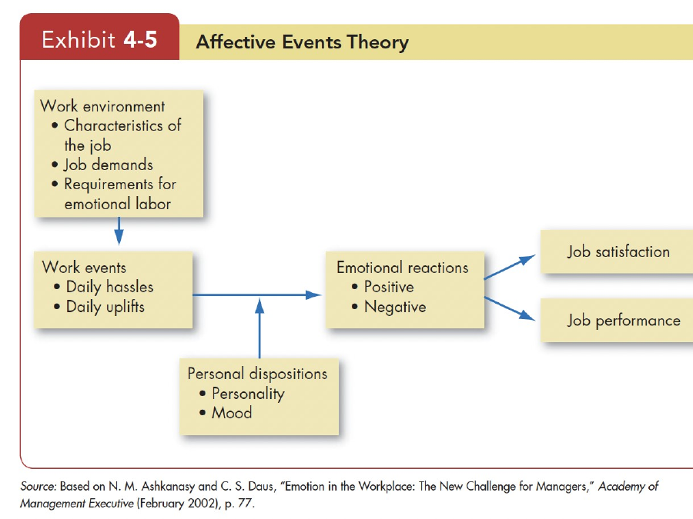
Exhibit 4-5 — Affective Events Theory.

AET components
Part of AET | Examples / role in the model
Work environment | Characteristics of the job, job demands, and requirements for emotional labor.
Work events | Daily hassles and daily uplifts.
Personal dispositions | Personality and mood.
Emotional reactions | Positive or negative reactions to work events.
Outcomes | Job satisfaction and job performance.

The model implies that the same event may not affect everyone identically because personal dispositions such as personality and mood influence the emotional reaction.
Perfect analytical structure
Work environment → work events (hassles/uplifts) + personal dispositions → emotional reaction → job satisfaction/job performance. Write this chain explicitly in an AET case answer.

5.12 Emotional Intelligence (EI)
Emotional intelligence: The ability to (1) perceive emotions in oneself and others, (2) understand the meaning of those emotions, and (3) regulate one’s emotions accordingly.
- Perceive emotions: accurately notice emotional information.
- Understand emotions: interpret what the feeling means and what may have caused it.
- Regulate emotions: modify the response so behavior remains appropriate and effective.
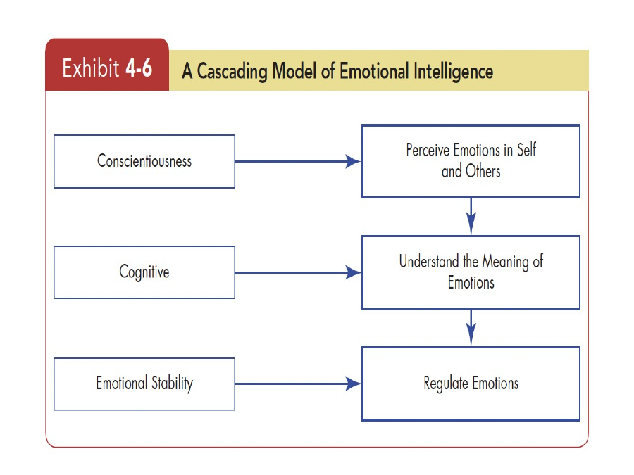
Exhibit 4-6 — Cascading Model of Emotional Intelligence.
The course’s cascading model maps conscientiousness to perceiving emotions, cognitive ability to understanding emotion meaning, and emotional stability to regulating emotions.

5.13 Emotion Regulation
Emotion regulation: Identifying and modifying the emotions you feel.
- Think about more pleasant things.
- Suppress negative thoughts.
- Distract yourself.
- Reappraise the situation.
- Engage in relaxation techniques.
For analytical questions, distinguish emotion regulation (managing the feeling) from emotional labor (managing what is displayed in a work interaction).

5.14 OB Applications of Emotions and Moods
Area | Course application
Selection | EI may be considered in hiring, especially in jobs requiring high social interaction.
Decision making | Moods/emotions affect decisions; positive emotions can enhance problem solving.
Creativity | People in good moods tend to be more creative and generate more ideas.
Motivation | Moods and emotions affect motivation.
Leadership | Effective leaders can use emotional appeals to convey messages.
Negotiation | Negotiation is emotional; a skilled negotiator may use a “poker face.”
Customer service | Employee emotional state affects customer service, repeat business, and customer satisfaction.
Emotional contagion | Catching emotions from others; employees’ emotions can transfer to customers.
Deviant workplace behavior | People may violate established norms and threaten the organization or its members.
Safety and injury | Bad moods can contribute to workplace injury.

6. Cross-Topic Analytical Links + Case Framework

6.1 The four most important “chains” to memorize
1. Individual inputs → emotions/moods + motivation/perception/decision making → attitudes/stress, task performance, citizenship, withdrawal.
2. Attitude components → cognition + affect + behavioral intention → possible behavior; if inconsistent, cognitive dissonance may motivate attitude/behavior change or rationalization.
3. AET → work environment → work events → emotional reaction (shaped by personal dispositions) → job satisfaction and job performance.
4. Job dissatisfaction → EVLN response; the response can influence turnover, absenteeism, deviance, and organizational outcomes.

6.2 Case-study answer template
Step | What to write
1. Identify | Name the exact concept (e.g., cognitive dissonance, surface-level diversity, emotional labor, AET).
2. Define | Give the course definition in 1–2 sentences.
3. Evidence | Point to the specific facts in the case that match the concept.
4. Apply | Explain the mechanism: how the concept produces the observed behavior/outcome.
5. Implication | State the organizational consequence and, when appropriate, the relevant management action.
6. Contrast | If two concepts are easily confused, explicitly distinguish them.

6.3 Concept contrasts that are frequently confused
Pair | Difference
Emotion vs mood | Emotion = intense + specific target + short; mood = less intense + general/unclear cause + longer.
Affect vs emotion | Affect is the umbrella term; emotion and mood are forms of affect.
Job satisfaction vs job involvement | Satisfaction = evaluation/feeling about job; involvement = psychological identification with job.
Organizational commitment vs POS | Commitment = attachment to organization; POS = belief that organization values/care about employee.
Citizenship vs task performance | Citizenship = discretionary beyond formal duties; task performance = core formal tasks.
Exit vs voice | Exit leaves; voice stays and tries to improve.
Surface vs deep diversity | Surface = easily perceived demographics; deep = values/personality/preferences.
Surface vs deep acting | Surface acting changes the display; deep acting tries to change the actual inner feeling.
Emotional labor vs emotion regulation | Emotional labor concerns workplace display rules/interpersonal transactions; emotion regulation is the broader process of identifying/modifying emotions.
EI vs emotional labor | EI = ability to perceive/understand/regulate; emotional labor = job requirement to display organizationally desired emotions.

6.4 Original Practice Case Bank (3 + 4 + 2)
These are original practice cases created from the supplied topics. They are not taken from the slides.

A. OB / Diversity — 3 cases
Case 1 — The New Plant Manager: A plant manager spends the day gathering operational data, then explains a new policy to employees, later appears at a community event, and finally negotiates a supplier contract.
Question: Identify the Mintzberg roles represented by the four activities.
Case 2 — The Promotion Conversation: Two employees have similar visible demographics, but one values autonomy while the other prefers close supervision. A supervisor favors the first employee because their work preferences fit the manager’s style.
Question: Is this surface-level or deep-level diversity? Which concept should you investigate if the preference becomes the basis for unfair treatment?
Case 3 — The Hiring Test: A company chooses a candidate because they score highly on number aptitude, verbal comprehension, inductive reasoning, and memory, while another candidate excels in physical stamina and dynamic flexibility.
Question: Classify the abilities being used and distinguish intellectual from physical ability.

B. Attitudes / Job Satisfaction — 4 cases
Case 4 — “I Hate This Job”: An employee believes their pay is unfair, feels angry, and plans to search for another employer.
Question: Identify the cognitive, affective, and behavioral components.
Case 5 — The Hypocritical Employee: An employee says safety rules are important but routinely ignores them. The employee later tells co-workers that “rules are too strict here anyway.”
Question: Explain cognitive dissonance and show the possible ways the employee could reduce it.
Case 6 — The Exit or Voice Decision: A team is unhappy about scheduling. One employee starts applying elsewhere. Another submits a constructive proposal to management. A third stays and waits. A fourth stops caring and lets work deteriorate.
Question: Classify all four responses using EVLN.
Case 7 — Satisfaction and Turnover: An unhappy employee receives an unsolicited external job offer but remains in the organization because outside alternatives are uncertain. Another unhappy employee in the same company leaves quickly because many jobs are available.
Question: Apply the course’s satisfaction–turnover relationship and explain why the outcomes differ.

C. Emotions / AET — 2 cases
Case 8 — The Customer Service Smile: A service employee is angry after a rude customer interaction but must speak warmly and politely. On another day, the employee deliberately reinterprets the situation and genuinely becomes calmer.
Question: Identify felt/displayed emotion, emotional dissonance, surface acting, and deep acting.
Case 9 — The Daily Hassle: Two employees face the same recurring software failures. One reacts with frustration and becomes dissatisfied; the other remains calm and solves the problem constructively. Their personalities and starting moods differ.
Question: Use AET to explain why the same workplace event produces different emotional reactions and different outcomes.

7. Practice Questions

7.1 Direct-definition / descriptive questions
1. Define organizational behavior and name its three determinants.
2. List Robbins’ four management functions.
3. Explain Mintzberg’s three role families.
4. Name the three management skills.
5. List Luthans’ four managerial activities.
6. Differentiate a successful manager from an effective manager.
7. What is surface-level diversity? What is deep-level diversity?
8. Define discrimination and list the six forms shown in Exhibit 2-1.
9. Define ability, intellectual ability, GMA, and physical ability.
10. List the seven dimensions of intellectual ability.
11. List the nine basic physical abilities.
12. What is diversity management? Explain attracting, selecting, developing, and retaining.
13. Define attitude.
14. Explain the cognitive, affective, and behavioral components of an attitude.
15. What is cognitive dissonance? How can a person reduce it?
16. Define job satisfaction, job involvement, psychological empowerment, organizational commitment, POS, and employee engagement.
17. Compare the two methods of measuring job satisfaction.
18. List the main causes of job satisfaction given in the slides.
19. Explain the EVLN responses to dissatisfaction.
20. Define affect, emotion, and mood.
21. Differentiate emotions and moods on at least five dimensions.
22. List the six essentially universal emotions in the course.
23. Define positive affect and negative affect.
24. Explain positivity offset.
25. Define emotional labor, emotional dissonance, surface acting, and deep acting.
26. Define Affective Events Theory.
27. Define emotional intelligence and its three abilities.
28. What is emotion regulation? List the strategies provided.
29. List ten OB applications of emotions and moods from the course.

7.2 Analytical questions
1. Why does the course say emotions are not necessarily the opposite of rationality? Use the decision-making point and Phineas Gage example.
2. Explain how cognitive dissonance can make behavior and attitudes move toward greater consistency.
3. A highly paid employee is dissatisfied. Explain why pay alone may not guarantee job satisfaction.
4. Explain why demographic diversity should not automatically be labeled good or bad for team performance.
5. How can a manager reduce the perception gap around job satisfaction?
6. Explain how positive employee attitudes can feed into a virtuous cycle.
7. Why might the same workplace event create different emotional reactions in two employees? Use AET.
8. Distinguish surface acting and deep acting with workplace examples.
9. Explain how emotional contagion can affect customer satisfaction.
10. Compare job satisfaction, organizational commitment, and perceived organizational support.

8. Six-Question Mock Exam
The syllabus says the exam has a total of 6 questions and includes descriptive, case-study, and analytical questions. It does not specify exact marks in the uploaded material, so this mock preserves the 6-question structure without inventing a mark scheme.

Q1 — Descriptive
Define OB. Explain the three determinants of behavior studied by OB and describe the basic OB model (inputs → processes → outcomes).

Q2 — Descriptive
Explain Mintzberg’s managerial roles. Give one case clue for each of the three role families.

Q3 — Case study
A company excludes some employees from informal mentoring, uses jokes about a demographic group, and awards promotions using stereotypes. Identify the forms of discrimination involved and explain why the situation matters for diversity management.

Q4 — Case study
An employee says “my supervisor is unfair,” feels angry about a promotion decision, and starts looking for another job. Identify the three attitude components and classify the response using EVLN.

Q5 — Analytical
Using Affective Events Theory, explain how a daily workplace hassle can influence job satisfaction and job performance. In your answer, include work environment, event, personal disposition, emotional reaction, and outcomes.

Q6 — Analytical + case
A customer-service worker must appear cheerful after a rude interaction. Explain emotional labor, felt vs displayed emotions, emotional dissonance, surface acting and deep acting. Then explain how emotional contagion could affect the customer.

Mock Exam Answer Skeleton
Question | Key concepts that must appear
Q1 | OB definition; individuals/groups/structure; inputs/processes/outcomes; levels.
Q2 | Interpersonal/informational/decisional + role examples.
Q3 | Exclusion; mockery/insults; discriminatory policies/practices; diversity management.
Q4 | Cognitive + affective + behavioral; dissatisfaction; Exit.
Q5 | AET chain + different personal dispositions can change reactions.
Q6 | Emotional labor; felt/displayed; dissonance; surface/deep acting; emotional contagion.

9. Last-Minute Revision Sheets

9.1 30-second OB sheet
OB = individuals + groups + structure → behavior → organizational effectiveness.
Remember | Formula
Management | P-O-L-C
Mintzberg | Interpersonal / Informational / Decisional
Skills | Technical / Human / Conceptual
Luthans | Traditional / Communication / HRM / Networking
OB levels | Individual / Group / Organization
Core outcomes | Attitudes & stress / task performance / citizenship / withdrawal / cohesion / functioning / productivity / survival

9.2 Diversity + ability memory sheet
Topic | Memory cue
Diversity | Surface = seen; Deep = values/personality/preferences.
Discrimination | Policies/practices; sexual harassment; intimidation; mockery/insults; exclusion; incivility.
Intellectual ability | Number, verbal, perceptual, inductive, deductive, spatial, memory.
Physical ability | 4 strength + 2 flexibility + coordination + balance + stamina.
Diversity management | Attract → Select → Develop → Retain.

9.3 Job satisfaction + attitudes memory sheet
Topic | Memory cue
Attitude | Cognitive + Affective + Behavioral.
Dissonance | Inconsistency → discomfort → change attitude / behavior / rationalize.
Job attitudes | Satisfaction; involvement; empowerment; commitment; POS; engagement.
Measurement | Global rating OR job facets.
EVLN | Exit / Voice / Loyalty / Neglect.
Performance links | Performance, OCB, customer satisfaction, absenteeism, turnover, deviance.

9.4 Emotions + moods memory sheet
Topic | Memory cue
Affect | Umbrella.
Emotion | Intense + specific target + short.
Mood | Less intense + general + longer.
Mood dimensions | Positive affect ↔ negative affect; high/low intensity.
Basic universal set | Happiness, surprise, fear, sadness, anger, disgust.
Emotional labor | Display rules at work.
Surface acting | Change display.
Deep acting | Change actual feeling.
AET | Environment → event → reaction → satisfaction/performance.
EI | Perceive → understand → regulate.
Regulation | Pleasant thoughts; suppress; distract; reappraise; relax.

9.5 “If you see this in a case, think this”
Case clue | Concept
“My belief and my action conflict.” | Cognitive dissonance
“I am planning to resign.” | Exit
“I submitted a constructive proposal.” | Voice
“I am waiting for things to get better.” | Loyalty
“I stopped caring and let the situation deteriorate.” | Neglect
“The employee is excluded from informal mentoring.” | Exclusion
“The worker smiles even though angry.” | Surface acting / emotional labor
“The worker tries to genuinely feel calm.” | Deep acting
“The same event affects two employees differently.” | AET + personal dispositions
“Customer catches the worker’s mood.” | Emotional contagion
“Difference in values/work preferences becomes important.” | Deep-level diversity
“Visible demographic difference.” | Surface-level diversity
“Mental math / logic / visual rotation.” | Intellectual ability dimensions
“Strength / flexibility / balance / stamina.” | Physical ability

9.6 Final 15-minute checklist before entering the exam
- ☐ Can I define OB in one sentence and state individuals/groups/structure?
- ☐ Can I write all 10 Mintzberg roles without looking?
- ☐ Can I reproduce the OB model: inputs → processes → outcomes?
- ☐ Can I list surface/deep diversity and all six discrimination forms?
- ☐ Can I list 7 intellectual + 9 physical abilities?
- ☐ Can I write the ABC components of attitude with examples?
- ☐ Can I explain cognitive dissonance with a case?
- ☐ Can I list all six major job attitudes?
- ☐ Can I write EVLN and classify a case quickly?
- ☐ Can I define affect/emotion/mood and compare them?
- ☐ Can I draw/explain the AET chain?
- ☐ Can I distinguish emotional labor, surface acting, deep acting, and emotional dissonance?
- ☐ Can I explain EI as perceive → understand → regulate?
- ☐ Can I give at least five OB applications of emotions/moods?
- ☐ Can I structure a case answer as Identify → Define → Evidence → Apply → Implication?
Last-minute priority
If time is very short, prioritize: OB definition + OB model; Mintzberg roles; Exhibit 1-3 contributions; diversity/discrimination; ability tables; ABC attitude components; cognitive dissonance; job attitudes + EVLN; emotion vs mood; emotional labor; AET; EI; and case-based application.

Source Coverage and Notes
Primary sources used:
- Uploaded syllabus RTF: “OB 1, 2, 3 + Emotions & Moods”; includes topic checklist and exam pattern.
- OB2.pptx: Introduction to Management & Organizational Behavior, 28 slides.
- OB3.pptx: Attitudes and Job Satisfaction, 22 slides.
- EMOTIONS AND MOODS.pptx: Emotions and Moods, 27 slides.

Coverage note
Every syllabus item visible in the uploaded RTF is addressed somewhere in this guide. Image-only exhibits in the PowerPoint files were also inspected and incorporated, including Forms of Discrimination, Dimensions of Intellectual Ability, Nine Basic Physical Abilities, the OB Model, Affective Events Theory, and the Cascading EI model.

Gap note
The syllabus mentions “OB 1 Objectives,” but no separate objectives content was present in the uploaded files. The guide therefore does not invent a missing objective list.

